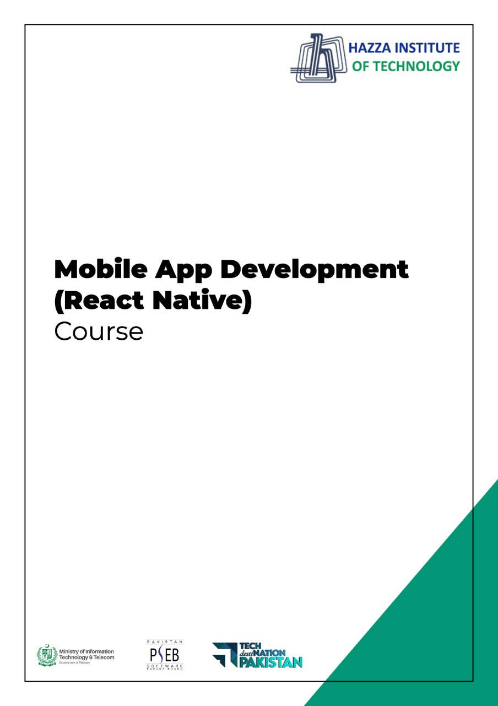

**(Flutter)**

Flutter Lab 6 (Session 1)

**Total Time:**

**3 hours (session-1)**

**Pre-Lab Activities:**

* + Student Must have Knowledge about External Resources calling.

**Learning Outcomes:**

* + Students will learn about external libraries
  + Students will learn more about layout widgets

**Student Activities:**

* + Design different color bars
  + Each bar create a sound

**Lab Tasks 1:**

**Create Xylophone app Audio playing application**

* + Create asset folder with all audio files
  + Create 7 Flat Buttons and upon click on each button Audio must be played , GUI of application is given bellow
  + 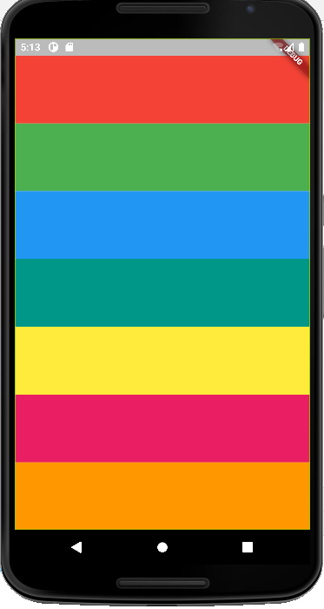Import audio player package in your dart file and use audio Cache methods to play files in assets.
  + All sounds are represnet as note1.wav, note2.wav, note3,wav, note4.wav, note5.wav, note6.wav, note7.wav.

**Lab Solutions:**

**LAB 6.1 :**

|  |
| --- |
| import 'package:flutter/material.dart';  import 'package:audioplayers/audioplayers.dart';  void main() => runApp(MaterialApp(  home: xylophone(),  ));  class xylophone extends StatelessWidget {  const xylophone({Key? key}) : super(key: key);  final player = AudioCache();    @override  Widget build(BuildContext context) {  return Scaffold(  backgroundColor: Colors.black,  appBar: AppBar(title: Text('Xylophone'),  ),  body: SafeArea(  child: Container(  child: Column(  crossAxisAlignment: CrossAxisAlignment.stretch,  children: [  Expanded(  child: TextButton(  style: ButtonStyle(backgroundColor: MaterialStateProperty.all(color)),  onPressed: () { player.play('note1.wav');  },  ),  )  Expanded(  child: TextButton(  style: ButtonStyle(backgroundColor: MaterialStateProperty.all(color)),  onPressed: () { player.play('note2.wav’);  },  ),  )  Expanded(  child: TextButton(  style: ButtonStyle(backgroundColor: MaterialStateProperty.all(color)),  onPressed: () { player.play('note3.wav’);  },  ),  )  Expanded(  child: TextButton(  style: ButtonStyle(backgroundColor: MaterialStateProperty.all(color)),  onPressed: () { player.play('note4.wav’);  },  ),  )  Expanded(  child: TextButton(  style: ButtonStyle(backgroundColor: MaterialStateProperty.all(color)),  onPressed: () { player.play('note5.wav’);  },  ),  )  Expanded(  child: TextButton(  style: ButtonStyle(backgroundColor: MaterialStateProperty.all(color)),  onPressed: () { player.play('note6.wav’);  },  ),  )  Expanded(  child: TextButton(  style: ButtonStyle(backgroundColor: MaterialStateProperty.all(color)),  onPressed: () { player.play('note7.wav’);  },  ),  )    ],  ),),  ),  );  }  } |